Black History Month
Social Media Toolkit

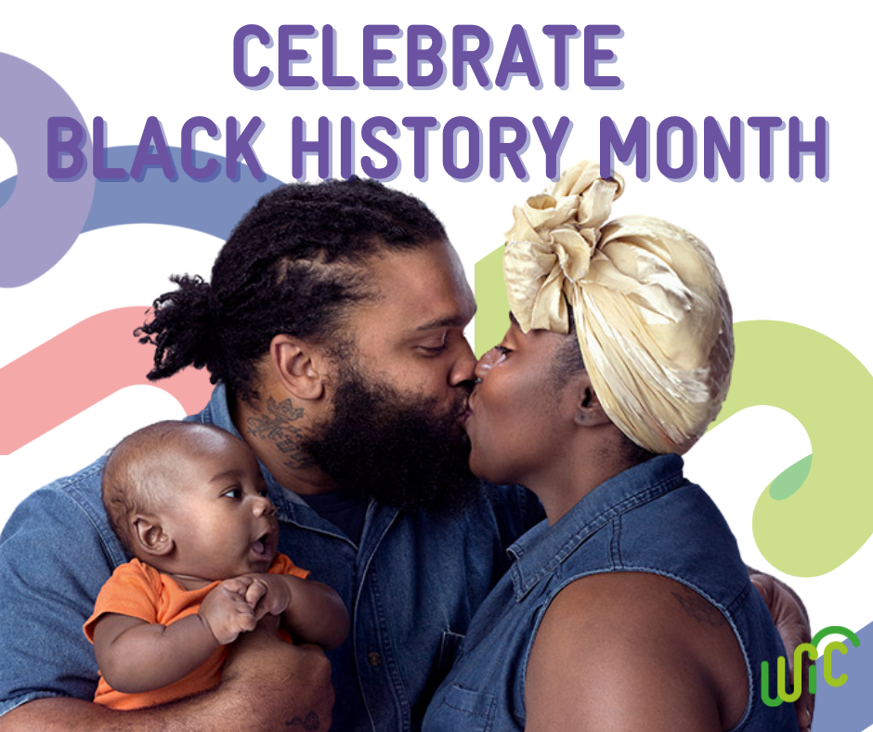
Each February, we celebrate #BlackHistoryMonth to honor the culture and contributions of Black Americans. The National WIC Association (NWA) has put together a toolkit to m. Simply copy and paste a message (or write your own) and post it to your social media! Download the related social media graphics here.

And don’t forget to follow NWA on Facebook, Twitter, Instagram, and LinkedIn to stay up-to-date with our advocacy, resources, and events!

Black History Month
- Happy #BlackHistoryMonth! WIC offers numerous services to support the health and well-being of Black families, like prenatal services, breastfeeding support, nutrition education, and health care referrals. Learn more: https://bit.ly/3Lpd8um
- Each year, #BlackHistoryMonth is celebrated throughout February to honor the culture and contributions of Black Americans. Join us all month long as we celebrate Black WIC staffers and participants!
- The 2022 #BlackHistoryMonth theme is Black Health and Wellness. Find health resources specifically for Black families, with topics including breastfeeding, maternal health, COVID-19, mental health, and other pressing issues here: https://bit.ly/34NXubc

Black Breastfeeding
- In the US, Black moms have the lowest rate of breastfeeding of any racial or ethnic group. WIC can help! Parents can find support, education, and community with WIC, no matter where they are in their #breastfeeding journey. #BHM

Engaging with Black Families
- Cheryl Lorie, a breastfeeding coordinator at Miami-Dade WIC, explains why inclusivity and engagement toward Black families are vital to strengthening the WIC program. #BHM https://bit.ly/3Bh9tue
- "Subject matter experts aren’t necessarily the community or culture experts. When planning and implementing initiatives, make sure the right people are at the table." This Florida breastfeeding coordinator explains how her WIC program engages Black families: https://bit.ly/3GFiQoj

