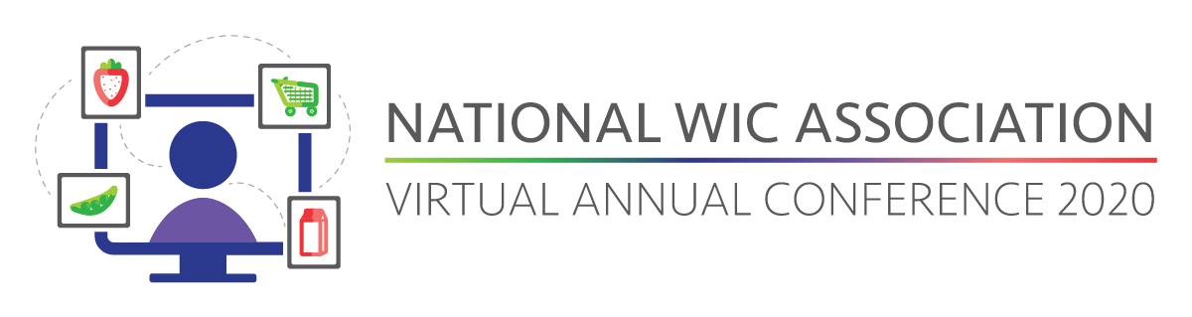
<Date>

Dear <Supervisor>:
The 2020 National WIC Association Virtual Annual Conference, held June 23-25, is a great opportunity to learn and connect with the WIC community. The theme of this year’s conference is Adapting to Change: Supporting the WIC Community. As the theme suggests, this conference will offer fresh ideas and insight into where the WIC program is headed, which is relevant to our current job challenges.
This is an important event for WIC professionals and is the premier event for our community. I believe by attending NWA’s Annual Conference, I will further my professional development and bring back new ideas to our agency and team. The conference will also offer an opportunity for me to hear from USDA officials and to discuss relevant updates and challenges the program faces. I will also have access to 25 general and concurrent sessions that are sure to expand my professional skills and knowledgebase.
I seek approval for the registration fee only, as no travel or lodging will be necessary. The conference registration fee is <find your fee at this link and fill it in here>.
Thank you in advance for the opportunity to gain valuable knowledge from industry experts and network with other WIC professionals. I look forward to coming back to <name of your organization> and sharing all that I learned at NWA’s Virtual Annual Conference 2020.
Additional information about the conference can be found at bit.ly/nwavirtual2020.
Sincerely,
<Your Name>

