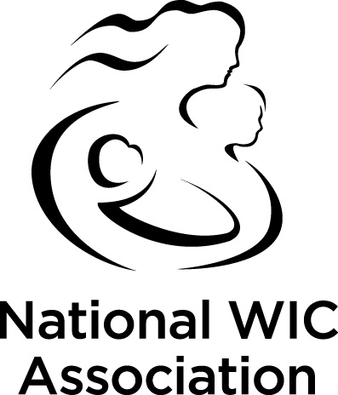

National WIC Association
2001 S Street Suite 580 Washington D.C. 20009-1165
Phone 202-232-5492 Fax 202-387-5281 www.nwica.org

TRAVEL MEMORANDUM

DATE: April 4, 2019
TO: NWA Board of Directors
FROM: Beth Beachy Douglas Greenaway
Board Chair President & CEO
SUBJECT: Summer Board of Directors Meeting, 2019

The NATIONAL WIC ASSOCIATION Board of Directors Summer Meeting will be held from July 16^{th -} 19th, 2019 at The Sir Francis Drake Hotel located in San Francisco CA.

The Sir Francis Drake Hotel
450 Powell Street.
San Francisco, CA 94102
Main Tel #: 1-415-392-7755 (Ref. NWA 2019 Summer Board of Directors' Meeting when calling)
You may contact the hotel to make your room reservations effective today. All reservations must be confirmed by Monday, June 24th, 2019 before 5:00 PM local time at the hotel on the cut-off date. Please reference the NWA 2019 Summer Board Meeting to get the negotiated room rate, which is the prevailing Federal Per Diem rate currently set at $270 per night, single/double occupancy, plus a 16.445% nightly room tax.

Should you wish to cancel your room reservations it must be done seventy two hours (72 hours) prior to your arrival date without penalty and a cancellation number provided. If reservations are cancelled within 72 hours of your arrival, your first night’s room deposit will not be refunded. Check-in time is at 4:00 PM and check-out time is at 11:00 Noon.

Access to the Hotel is available from the San Francisco International airport (SFO) by shuttle or taxi services. For information about SFO, click on the following URL to access their website www.flysfo.com.

A tentative travel agenda is included to assist you with your travel approval. A final agenda will be provided once completed.

Please do not hesitate to contact Pierre Francois at dfrancois@nwica.org or by phone on 202-232-5492 ext. 217 with any questions you may have.

